**PROJECT REPORT**

**Design and Development of Doctor’s Appointment Booking System Based on Patient Location**



A Project report submitted to the National University in partial fulfillment of the requirements for the Degree of Bachelor of Science (B.Sc.) in Computer Science & Engineering

**Submitted by:**

**Rezaul Alam**

Registration No. : 13502000498

Session : 2013-14

Department of Computer Science and Engineering

Institute of Science and Technology

National University, Bangladesh

**September 2018**

# DECLARATION

I hereby declare that this project report has been written based only on the works and results found by me. Material of the works or research or thesis by other researchers is mentioned by their references. This thesis, neither in whole nor in part, has been previously submitted for any degree.

**Submitted By:**

_ _ _ _ _ _ _ _ _ _ _ _

## Rezaul Alam

Roll No. : 13502000498

Registration No.: **13502000498**

Session : 2013-14

**ACKNOWLEDGMENT**

First of all we would like to thank the Almighty ALLAH. Today we are successful in completing our work with such case because Allah gave us the ability, chance, and a cooperating supervisor.

I have taken efforts in this project. However, it would not have been possible without the kind support and help of many individuals and organizations. I would like to extend my sincere thanks to all of them.

I am highly indebted to our respectable teacher Galib Hashmi for his guidance and constant supervisor as well as for providing necessary information regarding the project & also for support in completing the project.

I would like to express my special gratitude and thanks to industry persons for giving me such attention and time and encouragement mate in developing the project and people who have willingly helped their abilities.

Finally, I must acknowledge with due respect the content support and patient of our parents.

**APPROVAL**

This project “**Doctor’s Appointment Booking System Based on Patient Location**” Submitted to the Department of Computer Science and Engineering, Institute of Science and Technology affiliated with National University of Bangladesh is absolute fulfillment of the requirement for the degree of Bachelor of Science in Computer Science and Engineering.

**Signature of Internal Examine**r

**--------------------------------**

**Galib Hashmi**

*Assistant Professor*

*National University of Bangladesh*

###### 

**ABSTRACT**

“**Doctor’s Appointment Booking System Based on Patient Location**” is a smart appointment booking system that provides patients or any user an easy way of booking a doctor’s appointment online. This is a web based application that overcomes the issue of managing and booking appointments according to user’s choice or demands. The task sometimes becomes very tedious for the compounder or doctor himself in manually allotting appointments for the users as per their availability. Hence this project offers an effective solution where users can view various booking slots available and select the preferred date and time used to manage access to service providers. Many factors affect the performance of appointment systems which include arrival and service time variability, patient and provider preferences, available information technology and the experience level of the scheduling staff. Thus a proper scheduling system has to be developed by considering all these factors which will increase patient satisfaction, which in turn increases profit. An online scheduling system allows individuals to conveniently and securely book their appointments online. Compared to the usual queuing method, the web-based appointment system could significantly increase patient's satisfaction with registration and reduce total waiting time effectively. This paper focuses on detailed study of Doctor’s appointment System with architecture and merits.

**Table of Contents**

**Page No.**

###### DECLARATION ii

###### ACKNOWLEDGMEN iii

###### APPROVAL iv

###### ABSTRACT v

**CHAPTER 1: Introduction**

##### 1.1 Introduction of System 1

##### 1.2 Motivation 1

##### 1.3 Objectives 2

1.4 Methodology 2

1.5 Achievement 3

##### 1.6 Scope of work 3

##### 1.7 Outline of Dissertation 3

1.8 Summary 3

**CHAPTER 2: Literature Review**

2.1 Appointment system 4

2.2 Existing Applications 4

2.3 Learning system 5

2.4 Web application 5

2.5 Web application technology 5

2.5.1 HTML and CSS 5

2.5.3 PHP 6

2.5.4 SQLite 6

2.5.5 JavaScript 6

2.6 Third party libraries 6

2.7 Other idea 6

2.8 Summery 6

**CHAPTER 3: Background Study**

3.1 Introduction 4

3.2 System Development Life Cycle 4

3.3 Software Engineering 5

3.4 Database 5

**Page No.**

3.5 System Analysis 5

3.5.1 Waterfall Mode 5

3.5.2 Analysis 6

3.5.3 Design 6

3.5.4 Construction 7

3.5.5 Testing 7

3.5.5 Maintenance 7

3.6 Feasibility Study 8

3.6.1 Technical Feasibility 8

3.6.2 Software Availability 5

3.6.3 Hardware Availability 5

3.7 Summery 9

**CHAPTER 4: Appointment Booking System Based on Patient Location**

4.1 Appointment System Based on Patient Location 8

4.2 System Features 9

4.3 Advantage of “Appointment Booking System Based on Patient Location” 10

**CHAPTER 5: Analysis and Design**

5.1 Overview 7

5.2 System Study 7

5.3 System Analysis 8

5.3.1 Requirements Analysis 8

5.3.2 User Requirement 7

5.3.3 System Requirement 8

5.4 Functional Non-functional Requirement 7

5.5 Summary 8

**CHAPTER 6: Proposed system Process Model**

6.1 Methodology 10

6.2 Justification of Methodology 11

6.3 Description of Methodology 12

**CHAPTER 7: Proposed System Design**

7.1 Flow Chart 10

7.2 Block Diagram of System Module 11

7.3 Use case Diagram 11

7.4 Data Flow Diagram

**Page No.**

7.4.1 DFD Level 0 12

7.4.2 DFD Level 1 12

7.4.3 DFD Level 1 13

7.5 E-R Diagram 13

7.6 Algorithm

7.6.1 Searching algorithm 13

7.6.2 String Similarity 14

7.7 Summary 15

## CHAPTER 8: Implementation

8.1Technology Used In Application 15

8.2Hardware/Software Requirements

8.2.1 Minimum Hardware Requirement 16

8.2.2 Minimum Software Requirement 17

8.3 Implementation

8.31 Admin login page 17

8.3.2 Admin dashboard 17

8.3.3 Patient login page 18

8.3.4 Patient Dashboard 18

8.3.5 System Dashboard 19

8.4 Summary

## CHAPTER 9: System Testing

9.1 Introduction 8

9.2 Types of Testing 9

9.2.1 Functional Testing 11

9.2.2 Non-Functional/Performance Testing 11

9.2.3 Maintenance 12

9.3 Unit Testing 13

9.4 System Testing 13

9.5 Test Cases of the System 14

9.6 Benefits of Testing 15

9.7 Summary 16

## CHAPTER 9: Discussion and Conclusion

10.1 Discussion 17

10.2 Future Development 17

10.3 Conclusion 17

**References**  18

**List of Figure**

|  |  |  |
| --- | --- | --- |
| Fig. No. | Fig Title | Page. No. |
| 1.1 | Waterfall Model |  |
| 2.1 | Three Tier Architecture |  |
| 4.1 | System Flow chart |  |
| 4.2 | Block Diagram of system module |  |
| 4.3 | Use case diagram |  |
| 4.4 | DFD level 0 |  |
| 4.5 | DFD level 1 |  |
| 4.6 | DFD level 2 |  |
| 4.7 | E-R diagram |  |
|  |  |  |
|  |  |  |
|  |  |  |
|  |  |  |
|  |  |  |
|  |  |  |

# List of Tables

|  |  |
| --- | --- |
|  | **Page No** |
| Table 5.1: Hardware Requirement | 10 |
| Table 5.2: Software Requirement | 12 |
| Table 6.1: Test Cases | 12 |
| Table 6.2: Check Database Connection | 12 |
| Table 6.3: Check Student Registration Form | 12 |
| Table 6.4: Check Teacher Registration Form | 12 |
| Table 6.5: Check Login Credentials | 12 |
| Table 8.1: Application Tools |  |
| Table 8.2.1: Minimum Software Requirement | 12 |
| Table 8.2.2: Minimum Hardware Requirement | 22 |
|  | 34 |
|  |  |
|  |  |

**CHAPTER 1**

**Introduction:**

This chapter covers an introduction to the project including the context, a description of aims and objectives, a description of what will be achieved, contributions and the structure of the report.

* 1. **Introduction of System**

The term of “appointment” refer to the period of time allocated in the schedule to a particular patient’s visit and “service time” refer to the amount of time the physician actually spends with the patient (which may be shorter or longer than the appointment duration). Appointment scheduling can be classified into two broad categories static and dynamic. In static appointment scheduling all decisions must be made prior to the beginning of a session, which is the most common appointment system in healthcare. In dynamic appointment scheduling the schedule of future arrivals are revised continuously over the course of the day based on the current state of the system. This is applicable when patient arrivals to the service area can be regulated dynamically, which generally involves patients already admitted to a hospital or clinic. The appointment-scheduling process which is either dynamic or static can be viewed as burden in hospitals, which can be eliminated through an efficient online appointment scheduling system. The benefits of implementing this technology touch everyone involved in the scheduling process. Administrators and staff can conduct their tasks more efficiently and accurately, while patients have the ability to book their appointments and reservations quickly and more conveniently. Online appointment scheduling system is a system through which a user or simply, a patient can access the website of the doctor, and through the online software, the patient can easily make their appointments. In addition to that, patient can also provide additional information to the doctor, making the doctor aware of their situation and giving the doctor time to prepare the necessary information for when the patient’s arrives. In this way, online appointment scheduling can help the practitioner, the office staff, and the patient’s. There is several online appointment scheduling tools in the marketplace, some of which are feature-loaded, easy to setup and cheap. For doctors, online appointment scheduling brings a lot of value add services and benefits, like engaging the patient, making the patient feel appreciated, and being able to store patients’ data securely for future reference. But the most wonderful and useful advantage is that online appointment scheduling is amazingly low cost.

**1.2 Motivation**

Now a day’s population is growing rapidly. It is very difficult task to manage patient’s serial. If anybody is ill and wants to visit a doctor for checkup, he or she needs to visit the hospital and waits until the doctor is available. The patient also waits in a queue while getting appointment. If the doctor cancels the appointment for some emergency reasons then the patient is not able to know about the cancelation of the appointment unless or until he or she visits the hospital. In some cases patients do not come after booking an appointment. For this reason we have developed a booking system so that the patients can easily book a doctor from anywhere.

In our country population are increasing highly, in a report of WHO [1] in 2012 for every 15000 people there are about 7 doctor allocate. So this is a major problem. And patient are wait more time to get doctor’s appointment. People need to visit hospital or doctor’s chamber manually, it is more costly and time consuming. Sometime people need to meet immediately in nearest hospital or nearest doctor’s chamber. There are some existing system but these can’t fulfill the people’s requirement. This system will be solve these problem.

**1.3 Objectives**

Our modern age of technology is greatly depends on internet. Everything is converted to computer based for easier and faster communication. Here we tried to develop such a system, which will ensure some aspects,

* Reliability, maintainability, cost-effectiveness and a nice user-friendly environment.
* The objective of the project is to provide an opportunity of getting doctor appointment easily.
* Proper management of appointments, securely stores all records.
* Save money and time.
* User can book appointment from anywhere
* No need to paper work

**1.4 Methodology**

The design and development of the system followed the waterfall model as described below. The waterfall model follows a series of processes, which are used during development. Usually the stages will require the gathering of requirements and their analysis. The design of the system is the next stage, followed by coding the actual system. Then evaluation, testing and debugging, if necessary, is the next step. Finally the system will either be accepted and therefore maintained or rejected. It is 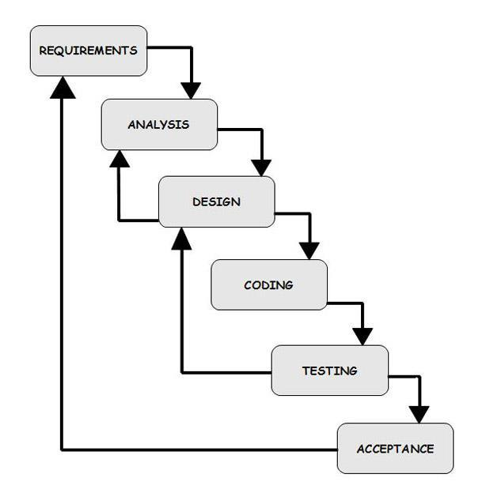vital to move to the next process of the waterfall model if the previous step has been completed.

**Figure 1.1** Waterfall model

**1.5 Achievement**

The following goals will be achieved

* Design and development of Doctor’s appointment system Based on Patient Location, which has been extended after being evaluated by user.
* Evaluated the extended system with user. The system will uses by potential people of our country.
* Complete a literature research in order to learn more about naturel language processing for predicting accurately.
* Investing existing tools and establish the requirements.

**1.6 Scope of work**

The scope of the project is to enable the users to search for doctors, get appointment. User can search doctors which can make user to find specific doctor an easy task .We implement this system for better user experience. This system is very easy to access. Also for establish real time communication, using modern and updated technology. So, user can see the update without reload or refresh. This system will compatible with user device such as pc, laptop, tab & smart phone. So user can easily access the system anytime anywhere. This system is very simple & user friendly so, any user can use this system easily.

**1.8 Summary**

A number of the novel concept have been incorporated to the system. A keyword matching algorithm has been used in combination with a string similarity algorithm to provide a better disease prediction. Also the Stanford parser has been used to analyze the structure of the given symptoms as described finally the system has been evaluated using feedback and logs from potential people that’s are use it.

**CHAPTER 2**

**Literature Review:**

This chapter contains the background research about topics relevant to the admissions communication. It presents an overview of virtual assistant and their interaction with humans. Furthermore the keyword matching and the template matching algorithms are mentioned, followed by real world examples of their use.

**2.1 Doctors Appointment Booking System Based on Patient Location**

An appointment system is to book doctor’s appointment near the patient location. It uses an appropriate interface for input and output and with the use of techniques it can suggest some doctor’s.

Patient can search doctor by location. Patient can book appointment any wherein Bangladesh. The implementation of such systems varies from using keyword matching, string similarity techniques. It is user friendly and less costly and less time consuming. User data is recorded into database for farther use.

###### **“Doctor’s Appointment System Based on Patient Location”** are computer programs that interact with users using searching algorithm**.”**

**2.2 Existing applications**

There are some existing system to get doctor’s appointment. Most of the time systems like that are based on the ways Doctorola [2] and Hospital Management System [3].

**Doctorola:** Doctorola is a doctor booking system. That is an online doctor appointment booking system. It is only an online appointment system. Hear we find only high quality hospital doctor in our country. It is the first online doctor appointment service platform in Bangladesh, providing real time doctor information and appointments through a fully integrated system. Doctorola is missioned to bring convenience in the healthcare service delivery for the general people in Bangladesh.

**Ibne Sian hospital management:** Hospital management system. This is use only get information about Ibne Sina hospital. There are some hospital in our county use website like these. The hospital is situated in Baghdad's [International Zone](https://en.wikipedia.org/wiki/Green_Zone) and was run by the [United States Armed Forces](https://en.wikipedia.org/wiki/United_States_Armed_Forces) from shortly after the downfall of [Saddam Hussein](https://en.wikipedia.org/wiki/Saddam_Hussein) in 2003 until 30 September 2009. The hospital was staffed mainly by the US Army and its rotating [Combat Support Hospital](https://en.wikipedia.org/wiki/Combat_Support_Hospital) units as an emergency facility for critically wounded soldiers and civilians, including suspected and confessed insurgents. During the period of US administration of the Ibn Sina, the emergency room saw an average of 300 [trauma](https://en.wikipedia.org/wiki/Physical_trauma) cases per month

**2.3 Web Application**

The classic architecture is the three tier architecture as described in Figure 2.1. The advantages of using this type of model is that the functionality is distributed across three independent systems and also that any of the tier can be replaced or upgraded independently if the requirements or the technology change.

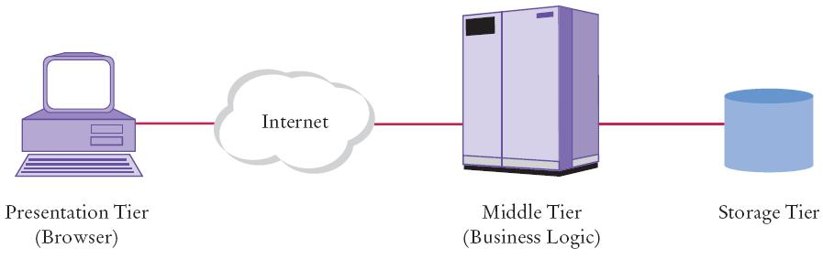

**Figure 2.1** Three Tier Architecture [4]

**2.4 Web application technologies**

A number of technologies and libraries were investigated for the purpose of development of this project and the following were identified as the ones to be used for creating the system.

**2.5.1 HTML and CSS**

HTML is the standard mark-up language used for the development of web interfaces. It must be used in combination with CSS, which is responsible for the layout of the HTML components. The CSS files have been based on the CSS files developed by Mike Stenhouse.

**2.5.2 PHP**

PHP is a widely-used open source general-purpose scripting language that is especially suited for web development and can be embedded into HTML. It use for backend configuration. It is most widely uses language.

**2.5.3 SQLite**

SQLite is an in-process library that is implements a [self-contained](https://www.sqlite.org/selfcontained.html), [server less](https://www.sqlite.org/serverless.html), [zero-configuration](https://www.sqlite.org/zeroconf.html) [transactional](https://www.sqlite.org/transactional.html) SQL database engine. The code for SQLite is in the [public domain](https://www.sqlite.org/copyright.html) and is thus free for use for any purpose, commercial or private. SQLite is the [most widely deployed](https://www.sqlite.org/mostdeployed.html) database in the world with more applications than we can count, including several [high-profile projects.](https://www.sqlite.org/famous.html) SQLite is an embedded SQL database engine. Unlike most other SQL databases, SQLite does not have a separate server process. SQLite reads and writes directly to ordinary disk files. A complete SQL database with multiple tables, indices, triggers, and views, is contained in a single disk file.

**2.5.4 JavaScript**

JavaScript is a scripting, client-side, programming language. It can be used to provide encase the functionality of HTML pages. It can be used for various purposes such as setting character limitations on text areas.

**2.6 Third party libraries**

The Jazzy spelling Java API has been used and requires an interaction with a local dictionary file in order to provide a spelling correction if necessary. The Google search Java API has been used and requires communication with the Google search server on user request. Also the ling pipe Java natural language processing API has been used for calculating the string similarity.

**2.7 Other ideas**

A combination of the keyword matching algorithm with the string similarity algorithm should be used. The keyword matching will start identifying keywords and retrieve the prediction that has the most keywords. In the case that the same number of keywords is found in more than one answer or there are no keywords then the String similarity algorithm will run to identify the question is most similar to the one entered and retrieve the answer

**2.8 Summary**

From the information gathered from the research the strongest points and weaknesses of each have been identified and a list of desired features that should be in the system has been created. Finally the conclusion was that the system should contain a combination of the keyword matching with the String similarity algorithm, a customized google search option and a spell checker, log and feedback functionality.

**CHAPTER 3**

**Background Study:**

**3.1 Introduction**

A background study is a preliminary analysis which is prepared to determine the relative environmental impacts associated with a proposed project. The ever changing trend in a technology brought the necessity for the automation of everything on from paper and pen based to absolute computer domination. The overwhelming emergence of computers paved way to easier increasing urbanity of modern information system allows the information and communication technologies to be utilized in different actions. In fact, the educational institutions are one of the leading users of application in order to manage student data.

**3.2 System Development Life Cycle**

The system development life cycle (SDLC) [5], also referred to as the application development life cycle, is a term used in systems engineering, information system and software engineering to describe a process for planning, creating, testing, and deploying and information system. The system development life cycle concept applies to a range of hardware and software configuration, as a system can be composed of hardware only, software only, or a combinations both. A system development life cycle is composed of a number of clearly defined and distinct work phases which are used by system engineers and system developers to plan for, design, build, test, and deliver information systems.

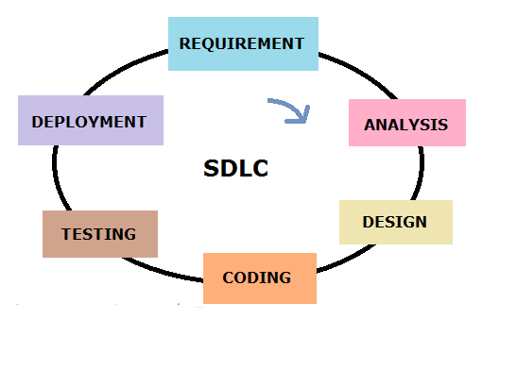

**Fig: 2.1 System Development Life Cycle**

Like anything that is manufactured on an assembly line, an SDLC aims to produce high-quality system that meet or exceed customer expectation, based on customer requirements, by delivering system which move through each clearly defined phase, within scheduled time frames and cost estimate. Computers system are complex and often (especially with the recent rise of service oriented architecture) link multiple traditional system potentially supplied by different software vendors. To manage this level of complexity, a number of SDLC models or methodologies have been created, such as “waterfall”; “spiral”; “Agile software development”; ”rapid prototyping”; “incremental”; and “synchronized and stabilize”;.

**3.3 Software Engineering**

Software engineering (SWE) is the application of engineering to the development of software in a systematic method. The definition, implementation, assessment, measurement, management, change and improvement of the software life cycle process itself. Software engineering models and methods impose structure on software engineering with the goal of making that activity systematic, repeatable, and ultimately more success oriented. Software engineering professional practice is concerned with the knowledge, skills and attitudes that

Software engineers must processes to practice software engineering in a professional, responsible, and ethical manner. Software engineering economics is about making decisions related to software engineering in a business context.

**3.4 Database**

A database is an organized collection of data. It is the collection of schema, tables, query, reports, views, and other objects. The data are typically organized to model aspects of reality in a way that supports process requiring information, such as modelling the availability of rooms in hotels in a way that supports finding a hotel with vacancies. A database management system (DBMS) is a computer software application that interacts with the user, other application, and the database itself capture and analyses data. A general –purpose DBMS is designed to allow the definition creation, querying, update, and administration of data base. Well known DBMSs include MySQL, PostgreSQL, MongoDB, MariaDB and Microsoft SQL server, Oracle, Sybase, SAP HANA, MemSQL and IBM DB2. A data base is not generally portable across different DBMSs, but different DBMS can interoperate by using standards such as SQL and ODBC or JDBC to allow to a single application to work with more than one DBMS. Database management system are often classified according to the database model that they support ;the most popular database system since the 1980 have all supported the relation model as represented the SQL language .[disputed- discuss] Sometimes a DBMS is loosely referred to as a database’. Existing DBMSs provide various functions that allow management of a database and its data which can be classified into four main functional group:

* Data definition – Creation, modification and removal of definition that define the organization of data.
* Update – Insertion, modification and deletion of the actual data.
* Retrieval – providing information in a form directly usable or for further processing by other applications. The retrieved data may be made available in a form basically the same as it is stored in the database or in a new from obtained by altering or combining existing data from the database.
* Administration – Registering and monitoring users, enforcing data security, monitoring performance, maintain data integrity, dealing with the concurrency control, and recovering information that has been corrupted by some event such as an unexpected system failure.

**3.5 System Analysis**

The system analysis is a detailed study of the various operation performed by the existing system and their relationships within and outside of the system. One aspect of analysis is defining the boundaries of the system and determining weather a candidate system should other related systems. Here I completed system analysis by the input analysis and output analysis of existing system. At the preliminary stage of the analysis, we had followed the Waterfall Development Methodology.

**3.5.1 Waterfall Model**

The waterfall model is a sequential software development process. In which progress is seen as flowing steadily downwards through the phases of Connection, Initiation, Analysis, and design, Construction, Testing and Maintenance.

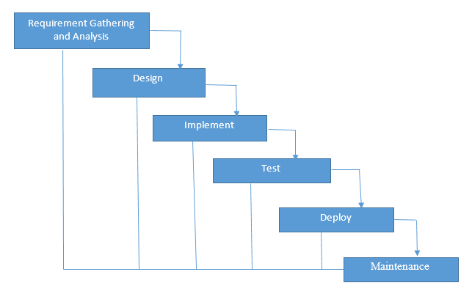

**Fig 2.2 Waterfall Model**

**3.5.2 Analysis**

Software analysis patterns or analysis are conceptual models, which capture abstraction of a situation that can often be encountered in modelling. Using species analysis, we will do a system-risk-analysis. Based on the results of this analysis, we will define a test concept adapted to the risk requirements.

**3.5.3 Design**

A design pattern is a general reusable solution to a commonly problem in software design. A design pattern is not a finished that can be transformed directly into code. In this section, we will work for how to solve a problem that can be used many different situations.

**3.5.4 Construction**

Construction means the implementation or the realization of an application, or execution of a plan, idea, model, design, specification, standard, or policy. In computer science, a construction is a realization of a technical specification or algorithm as a program, software component. Many implementation may exist for a given specification or standard. So, in this phase we will build up our application.

**3.5.5 Testing**

Software testing is an investigation about the quality of the product or service under test. Software testing can be also provide an objective, independent view of the software to allow the business to appreciate and understand the risks of software implementation. Test techniques include, but are not limited to the process of executing a program or application with the intent finding software bugs (errors or other defects).

Several testing types are available:

* Black Box testing
* White Box Testing
* Alpha Testing
* Beta Testing
* Software application Testing

**3.5.6 Maintenance**

Maintenance is the modification of a software product after delivery to correct faults , to improve performance or other attributes. We will be responsible to solve for all kinds of software faults after delivery.

**3.6 Feasibility Study**

A feasibility study is an evaluation of a proposal designed to determine the difficulty in carrying out a designated task. Generally, a feasibility study precede technical development and project implementation.

* Technical Feasibility
* Software Feasibility
* Hardware Feasibility

**3.6.1 Technical Feasibility**

Technical feasibility is the process of providing that the concept is technical possible. The objective of Technical Feasibility step is to confirm that the product will perform and to make sure that there are no production barriers.

Technical Feasibility is carried out to determine whether has the capability, In terms of software, hardware, personnel and expertise, to handle the completion of the project.

**3.6.2 Software Availability**

For implementing the project a couple of software is needed. First of all need an OS and various software specially LAMP/XAMPP/ WAMP server. Any OS is compatible such as, Window OS, GNU-LINUX OS or Ubuntu OS.

**3.6.3 Hardware Availability**

For this application you need to have an internet facility and PC hardware configuration which can run a standard browser for quick loading and response time of the application.

**3.7 Summary**

The trend feasibility study suggest the need os a new information system to keep pace with the modern world. A system is never quite infeasible. It is often more or less feasible from different perception and perspectives. The earlier sections discussed all the feasibility checkpoints and respective problems and conditions.

**CHAPTER 4**

**Appointment Booking System Based on Patient Location**

**4.1 Introduction**

An online system is also known as a web based system. A web is made up of page that is commonly known as web page or web site, and a web site is a computer program that runs a web server that provides access to a group of related web pages. A system is a set of independent components working together to achieve a common objective. Therefore a web based system is a system that is accessible over the internet by a user in order to achieve a particular task for a given purpose. The Internet is a system that is use to connect computers and computer networks. It helps to link millions of computer networks all over the world and it allows the users to get information stored on other computers from a long distance. According to Chua (2010) the public demand for better healthcare system and the alarming number of missed appointments have forced the healthcare sector to recognize how they deliver care services. With the advance of IT technology today and seen healthcare system as a critical system, appointment booking system lies at the intersection of delivering efficient, dependable and timely access to health services. The conventional way of appointment booking is via fax, phone or email. But with the growing internet penetration, healthcare industry is moving towards the use of an online appointment booking system. There are several ways of making an appointment. A person can either go to the hospital directly for consultation day by day or make an appointment from home through phone call or email if his condition is not emergent. The Internet provides a wide range of technologies that enable hospitals to communicate with their patients. Recently, as the prevalence of Internet increasing, many hospitals initiated the website appointment system. Electronic patient-provider communication promises to improve efficiency and effectiveness of clinical care.

**4.2 System Feature**

According to Dexter, managing patient appointment system is a computer application used to manage and reduce the patient waiting time in the health care center. Some health care centers do not use any appointment system. So it has a longer average patients’ waiting time than the health care center that adopts the patients’ appointment system. While patients can wait for more than one hour to be attended to by a physician in a health care center, they also can feel that they are being disregarded and treated unfairly. So when patients are given the time of appointment in a health care center, they can evaluate the quality of service in the center. Therefore the appointment schedule represents the real situation in the health care center faced by patient appointment schedulers. On the other hand, the standard practice for scheduling and processing patient appointments are based on the nature of treatments of the patients and that better approaches more sensitive to patient needs are desirable.

**4.3 Advantage of “Appointment Booking System Based on Patient Location”**

Online appointment booking is certainly more efficient than having to work schedules back and forth over the phone. In this way online appointment bookings save time and money and also allow receptionists more time to dedicate to their patients' needs. They also provide you - as a patient - and the doctor much information about an upcoming appointment – doctors can be more prepared. Automated reminders reduce ‘no-shows’. Finally, it is often inconvenient to talk about ailments over the phone, either in public or with a secretary you do not know.

In East Africa, DAKTARI.NET provides an efficient online booking service that not only serves the needs of individual practices but you can book an online appointment for various hospital departments too. In Kenya many doctors have a variety of affiliations with hospitals and many schedules. DAKTARI.NET allows Doctors to setup various schedules and you as patient to conveniently book an appointment on the schedule that is most convenient for you.

**CHAPTER 5**

**Analysis and Design:**

###### This chapter contains an overview, a system proposal and a thorough analysis of functional, non-functional requirements and users of the system.

**5.1 Software Design Description**

The Software Design Description specifies the required information content. It provides an architectural overview, logical design, detail design, physical design and application design of the System. It aims to provide everybody a clear understanding of the system. It must contain all the design information needed by users. This document user may not have the same level of system understanding. So they may need a selected portion of SDD. But it should be collected and presented in a way that assures completeness. It describes design decisions, architectural design, and the detailed design needed to implement the system. Typically, SDD is prepared to support the development of a software item. This information will farther can be used for analysis, planning, implementation, development and evaluation of the software system, by identifying and addressing essential design concerns.

The main purpose of SDD is,

* Identify required system resources.
* Describe functional structure, algorithm and process.
* Can be used to impact the requirement change.
* Need for maintenance activity

**5.2 System Study**

The study was carried out at Patient, Doctors and Hospital the main purposed of the study was to find out how the process of recording patient’s data is carried out. The system that is currently being used in Patient, Doctor and Hospital is entirety manuals. When a patient requests all the information is recorded manually from the appointment then the system are very lazy and more hesitation from the real information, doctor availability and proper time maintenance of the doctor appointment system.

**5.3 System Analysis**

During the system study phase, requirements of Online Doctor Appointment Booking System were categorized into user requirements, system and hardware requirements.

**5.3.1 Requirements Analysis**

Requirements are a feature of a system or description of something that the system is capable of doing in order to fulfill the system’s purpose. It provides the appropriate mechanism for understanding what the team wants, analyzing the needs assessing feasibility, negotiating a reasonable solution, specifying the solution unambiguously, validating the specification and managing the requirements as they are translated into an operational system.

**5.3.2 User Requirement**

During data collection, we investigated and found out how the current system operates, not only that but also tried out which problems are faced and how best they can be settled. The users described some of the basic requirements of the system this includes Search for Patients, Register Patient, Update record, Doctor information record, view doctor availability record and view all types of reports.

**5.3.3 System Requirement**

This section describes the hardware components and software requirements needed for effective and efficient running of the system

|  |  |  |
| --- | --- | --- |
| **SL** | **Hardware** | **Minimum System Requirement** |
| 01 | Processor | 2.4 GHz Processor speed |
| 02 | Memory | 2 GB RA |
| 03 | Disk Space | 320 GB |

**Table: 5.1 Hardware Requirement**

|  |  |  |
| --- | --- | --- |
| **SL** | **Software** | **Minimum System Requirement** |
| 01 | Operating System | Windows Server 2008,Windows7 |
| 02 | Database Management System | SQL, SQlite |
| 03 | Runtime Environment | PHP, django |

**Table: 4.2 Software Requirements**

**5.4 Functional & Non Functional Requirements**

The following is the desired functionality of the new system:

Accept of submissions in form of raw patients; perform analysis of financial to authenticate the users of the system.

And non-functional requirement include the following:

The system must verify validate all user input ant user must be notified in case of errors detected in the database, the system should allow room for expansion.

**3.4 Conclusion**

The responsibility of the administrator will be to maintain the system by adding questions and answers to the database and by updating current information sets when necessary. There are several security issues which need to be taken into consideration when designing the system. These include personal and sensitive information. The data should not be accessed without authorization and authentication. Disclosure or leak of data should be protected against various types of attacks and be encrypted and password protected.

**CHAPTER 6**

**Proposed system Process Model:**

**6.1 Methodology**

* Waterfall Model

**Requirement**

**Analysis**

**System**

**Design**

**Implementation**

**Testing**

**Development**

**Maintenance**

**Fig. 6.1: Waterfall model [2]**

**6.2 Justification of Methodology**

Every software developed is different and requires a suitable SDLC approach to be followed based on the internal and external factors. Some situations where the use of Waterfall model is most appropriate are:

* Requirements are very well documented, clear and fixed.
* Product definition is stable.
* The project is short.
* Simple and easy to understand and use
* Easy to manage due to the rigidity of the model. Each phase has specific deliverables and a review process.
* Phases are processed and completed one at a time.
* Easy to arrange tasks.

**3.3 Description of Methodology**

The sequential phases in Waterfall model are:

* **Requirement Gathering and analysis:** All possible requirements of the system to be developed are captured in this phase and documented in a requirement specification doc.
* **System Design:** The requirement specifications from first phase are studied in this phase and system design is prepared. System Design helps in specifying hardware and system requirements and also helps in defining overall system architecture.
* **Implementation:** With inputs from system design, the system is first developed in small programs called units, which are integrated in the next phase. Each unit is developed and tested for its functionality which is referred to as Unit Testing.
* **Integration and Testing:** All the units developed in the implementation phase are integrated into a system after testing of each unit. Post integration the entire system is tested for any faults and failures.
* **Deployment of system:** Once the functional and nonfunctional testing is done, the product is deployed in the customer environment or released into the market.
* **Maintenance:** There are some issues which come up in the client environment. To fix those issues patches are released. Also to enhance the product some better versions are released. Maintenance is done to deliver these changes in the customer environment.

All these phases are cascaded to each other in which progress is seen as flowing steadily downwards (like a waterfall) through the phases. The next phase is started only after the defined set of goals are achieved for previous phase and it is signed off, so the name "Waterfall Model". In this model phases do not overlap

**CHAPTER 7**

**Proposed System Design:**

In this chapter we introduce our project outline. How the system work. This system work by some part discuss these.

**7.1 Flow chart for the system**

This section discuses about flow chart of the “Appointment Booking System Based on Patient Location” Patient registration and login authenticate by administration by checking data from the database. And patient can select doctor for appoint and system check the availability of time slot and give permission to the patient for booking and patient input their details and get appointment and all data are store into database.

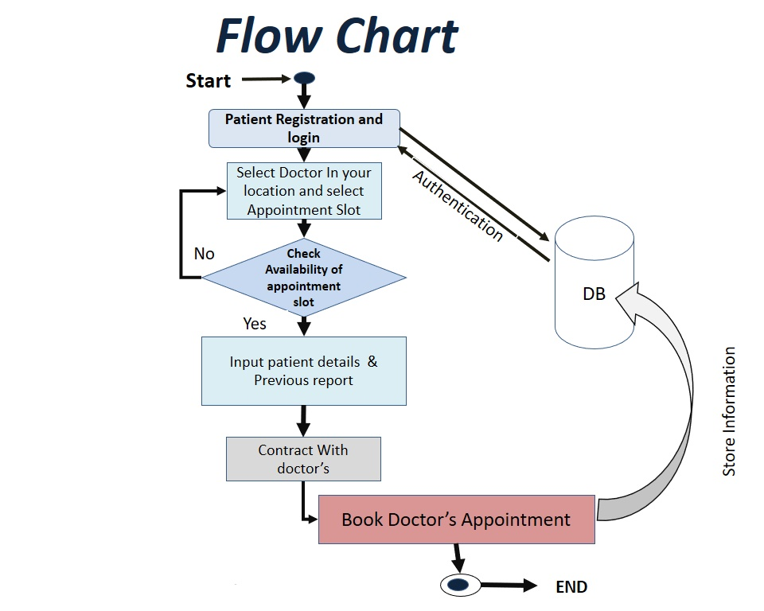

**Figure 7.1** System Flow chart

**7.2 Block Diagram of system module**

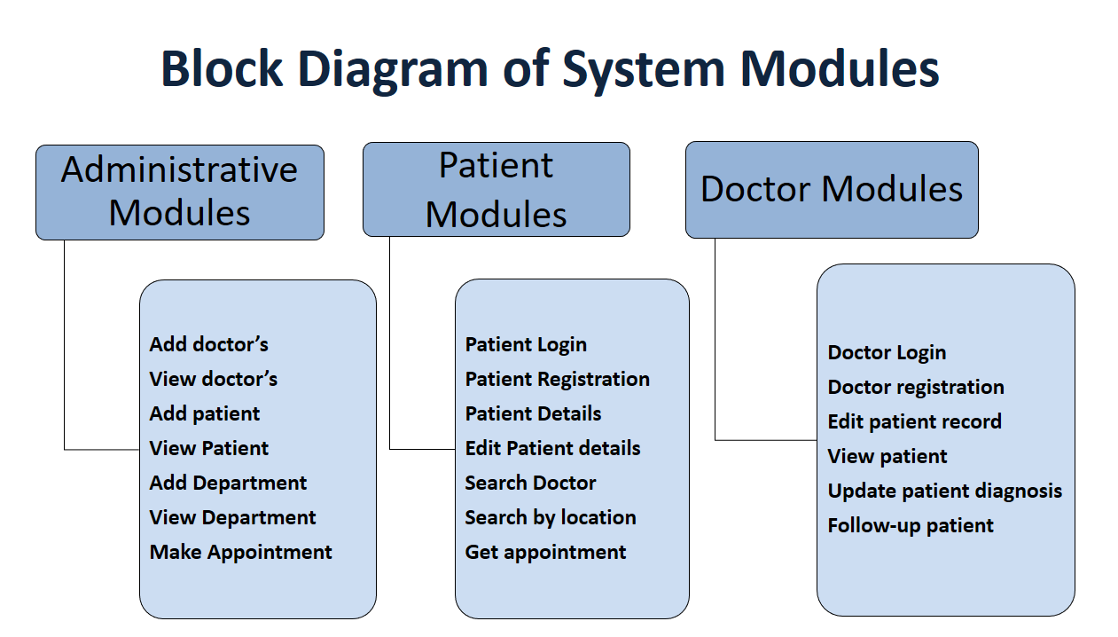

**Figure 7.2** Block Diagram of system module

In this diagram discuses about block diagram of “Appointment Booking System Based on Patient Location”. Here this system work with three module. There are administration module, Patient module, Doctor’s module, Admin can control all system and patient and doctor are the user of this system.

**7.3 Use case diagram for the system**

The use case diagram describes the functionality of the system as designed from the requirements and can be found below. In this use case diagram patient can login and after authentication patient can access and update profile, search doctor, find doctor by their location and patient can contact with doctor by using doctor’s contract information. And patient can book appointment easily. And this system can control everything.

And doctor also login the system with mail id and password after get permission to access the system doctor can edit her or his own profile and follow up patient and update patient diagnosis details for farther user.

Here controller is admin role admin can delete user or patient or doctor and ca edit both doctor and patient and self. Admin is controlled by database administration. So this is about this flow chat details and working flow.

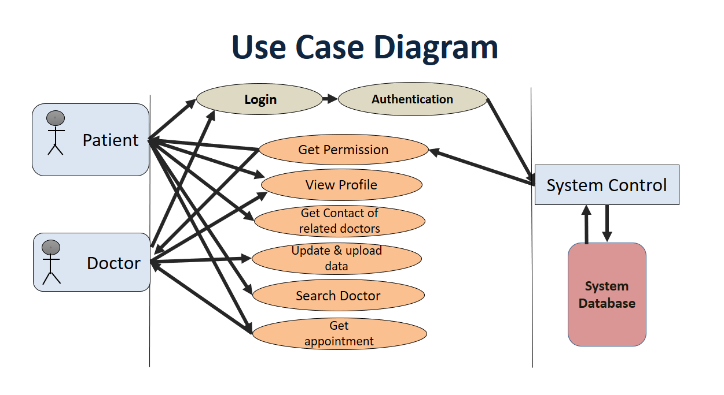

**Figure 7.3**: Use case diagram

# 7.4 Data flow diagram for the system

**7.4.1** **Data flow diagram level 0**

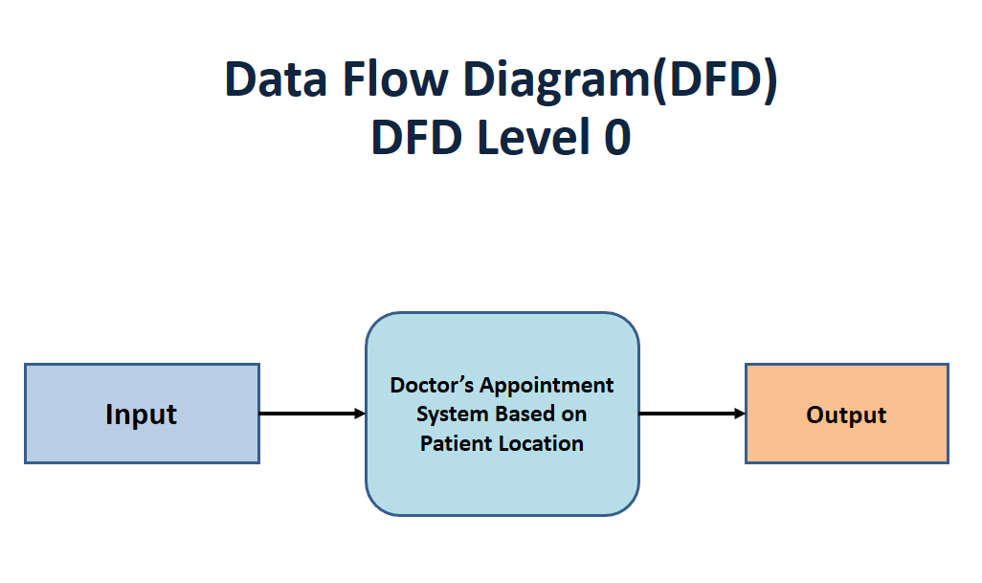

**Figure 7.4** DFD level 0

7.4.2 **Data flow diagram level 1**

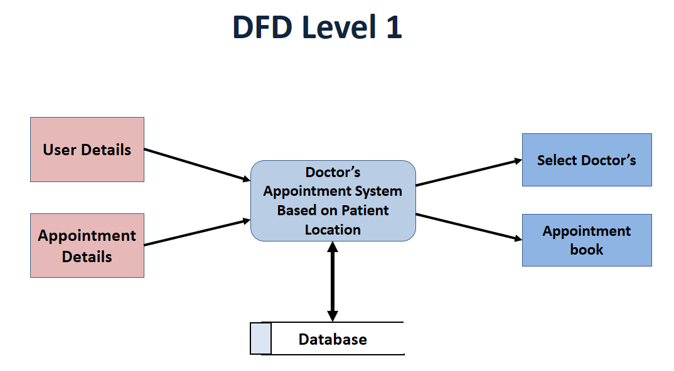

**Fig 7.6** DFD level 1

7.4.3 **Data flow diagram level 2**

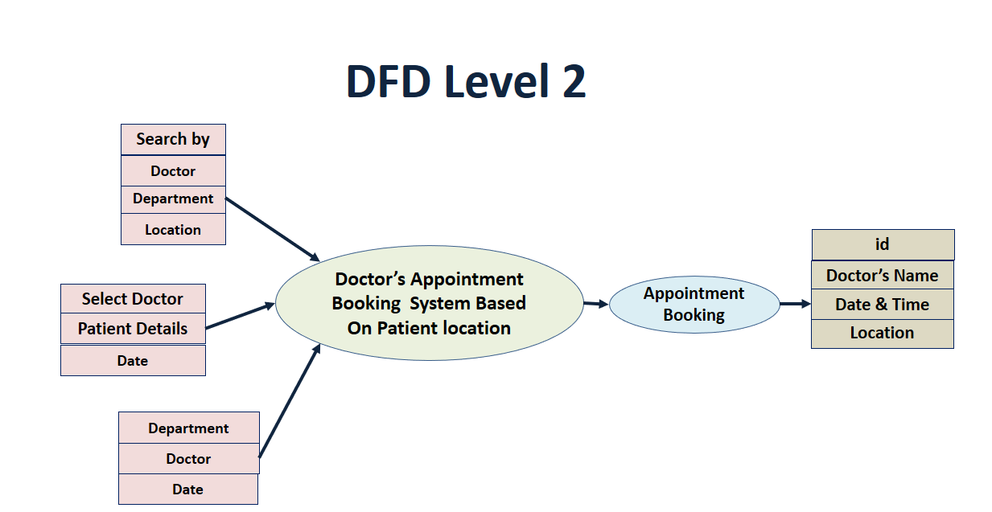

**Figure 7.5** DFD Level 2

**7.5 Entity Relationship (E-R) diagram for the proposed system**

An entity relationship diagram (ERD) shows the relationships of entity sets stored in a database. An entity in this context is a component of data. In other words, ER diagrams illustrate the logical structure of databases. An entity relationship diagram is a means of visualizing how the information a system produces is related.

**Entity**

Which are represented by rectangle. An entity is an object or concept that has its existence in the real world. It includes all those things about which data is collected. A weak entity is an entity that must defined by a foreign key relationship with another entity as it cannot be uniquely identified by its own attributes alone.

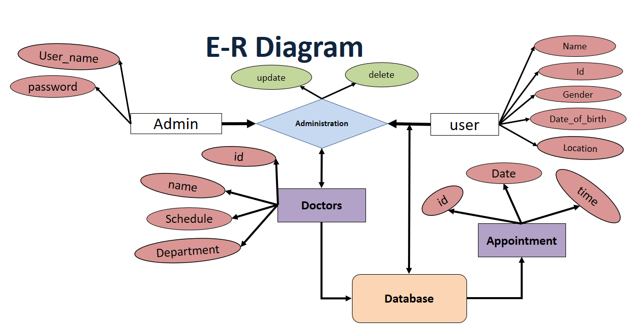

**Figure 7.7** E-R Diagram

**Attribute:**

Which are represented by oval. A key attribute is the unique, distinguishing characteristic of the entity. For example, an employee's social security number might be the employee's key attribute.

**Relationship:**

Relationship will be several implicit relationships among various entity types whenever an attribute of one entity to another entity type some relationship exists. Relationship symbol is:

**7.6 Algorithm**

**7.6.1 Searching algorithm**

This is an ANN (Artificial Neural Network) algorithm. The keyword matching algorithm will attempt to identify keywords in a sentence. In the case that one or more keywords are found in the user's input text then an answer will be retrieved. However, in the case that the same number of found keywords exist as keys for more than one answer then there is a deadlock. Again a deadlock occurs in the case that there are no keywords.

Consider the following example in order to understand better how the keyword matching algorithm works. The table represents a small number of information rows from the database of the system.

###### The user then submits their symptoms “Does a 2.2 in computer science satisfy the entry requirements for the M.Sc in computer security?”

###### The algorithm will identify both keywords in the second row and will retrieve the answer.

**7.6.2 String similarity**

The string similarity algorithm will try to find similarities between a list of strings and will retrieve the answer that is the closest match to the question submitted by the user. We will construct hashing function to understand the string similarity.

**7.6.3 Combination of algorithms**

In order to achieve the best possible outcome we decided to combine the two algorithms. Therefore to the database of the system has been added questions with both answers and keywords and questions with answers but no keywords. For example the keyword matching algorithm will search the keywords and the string similarity algorithm will search all pre-stored questions with or without keywords. In order to improve this similar questions have been added that have the same answer. Basically if the keyword matching fails then we try to think the way a simple user would think, asking a question.

Then the keyword matching algorithm will run first in order to identify keywords. It will identify one keyword in the first information line, one in the second and none in the third and so a deadlock occurs. In this case the string similarity algorithm will compare the pre-stored questions of the systems with the user's question and it will find that the best match is with the third entry in the table, even though there is no keyword in the database. It will then retrieve the answer of the third one. We can see here that the questions are very similar and have the same answer.

**4.7 Summary**

In this case the string similarity algorithm will compare the pre-stored questions of the systems with the user's symptoms and it will find that the best match is with the third entry in the table, even though there is no keyword in the database. It will then retrieve the answer of the third one. We can see here that the questions are very similar and have the approximate prediction base on patient input symptom.

**CHAPTER 8**

**Implementation:**

**8.1 Technology Used In Application**

Table 8.1: Applications Tools

|  |  |
| --- | --- |
| **Front-end** | **Back-end** |
| HTML5, CCS3, Bootstarp4, JavaScript | PHP7 , MySQL |

**8.2 Hardware / Software Requirement**

Every software have some minimum and maximum requirement for run the system. Minimum software requirement and hardware requirement to use this application is given below.

**8.2.1 Minimum Software Requirement**

**Table 8.2.1: Minimum Software Requirement**

|  |  |
| --- | --- |
| Operating System | Windows xp or Any compatible OS |
| Web Browser | IE 6.0 or Any compatible web browser |
| XAMPP | XAMPP-VM / **PHP** 7.2.9 |

* + 1. **Minimum Hardware Requirement**

**Table 8.2.2: Minimum Hardware Requirement**

|  |  |
| --- | --- |
| Processor | 1 MHZ |
| Ram | 512 |
| Hard Disk | 10GB (free space) |

* 1. **Implementation**
     1. **Admin Login**

Admin login page screenshot given bellow of the system of Appointment Booking System Based on patient location.

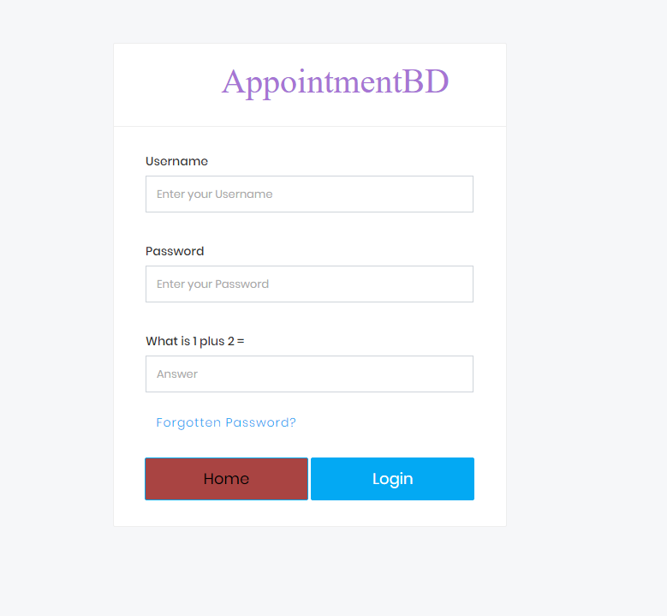

**Fig 8.3.1 Admin Login**

* + 1. **Admin Panel Dashboard**

Admin panel is the system admin dashboard and here the admin can control everything to the system and to the user patient and doctor, given bellow the admin panel dashboard screenshots of the system admin panel.

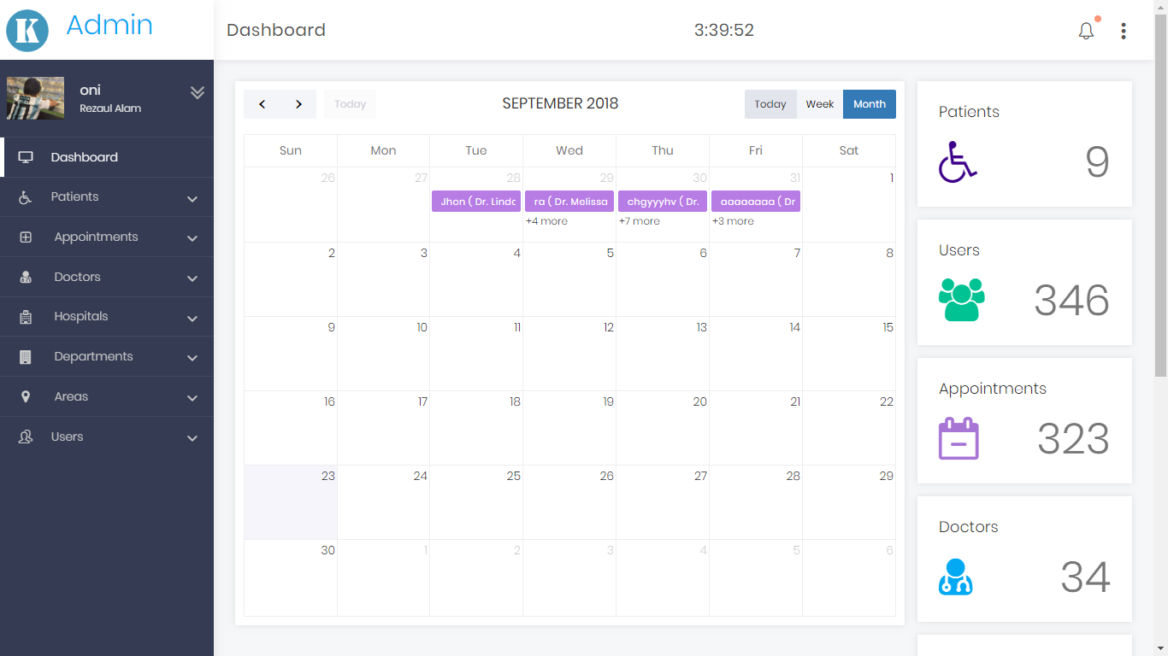

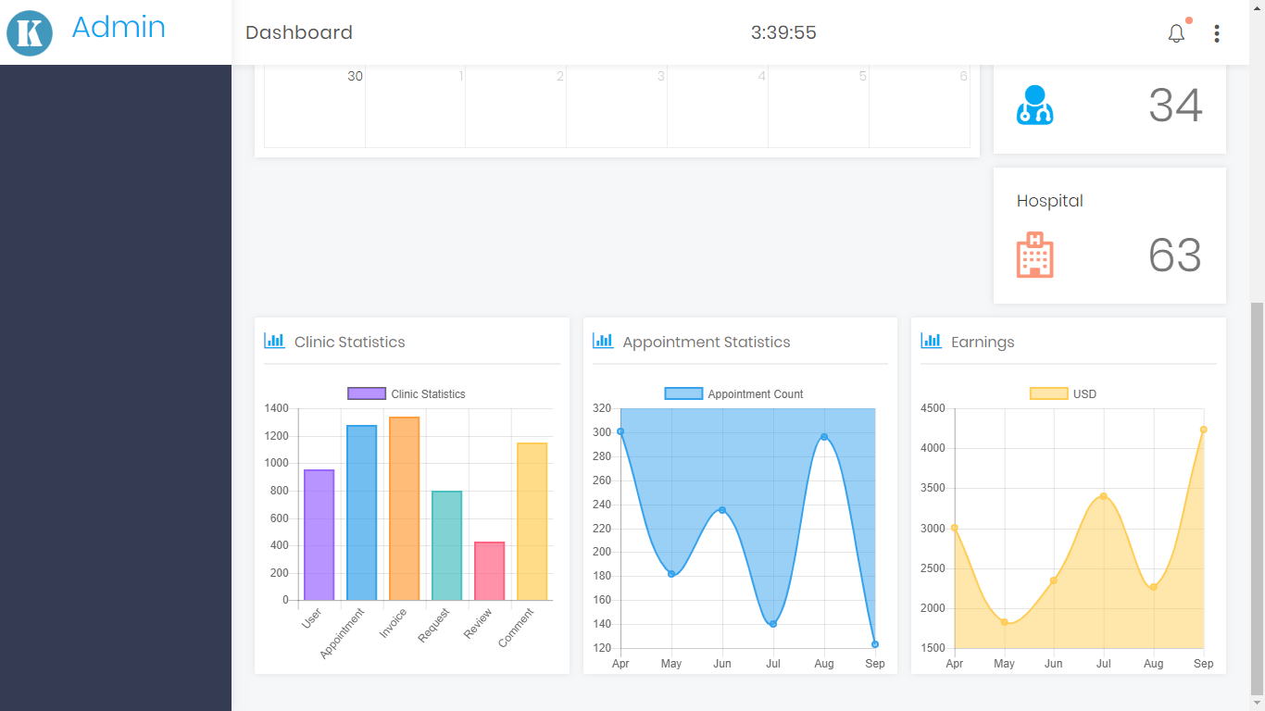

**Fig 8.3.2 Admin Panel Dashboard**

* + 1. **Patient Login Page**

Patient login page screenshot are given bellow.

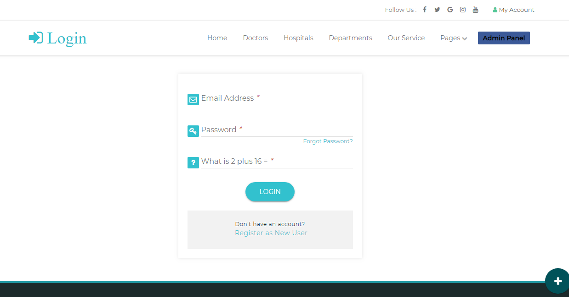

* + 1. **Patient dashboard page**

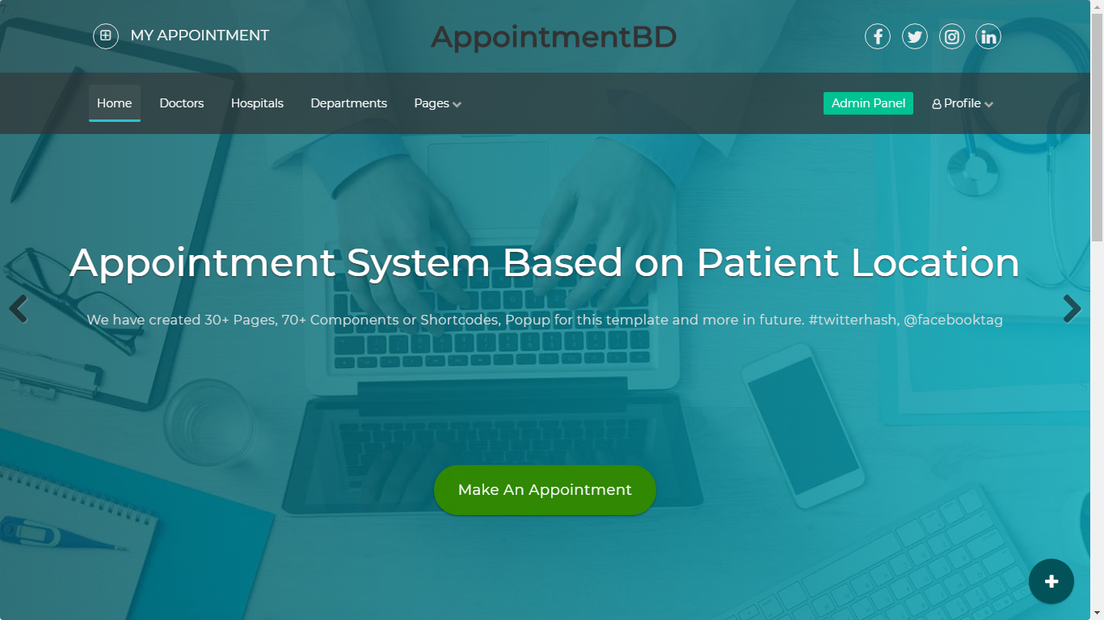

**Fig 8.2.5 patient dashboard**

* + 1. **System Dashboard Page**

System dashboard page screenshot are given bellow.

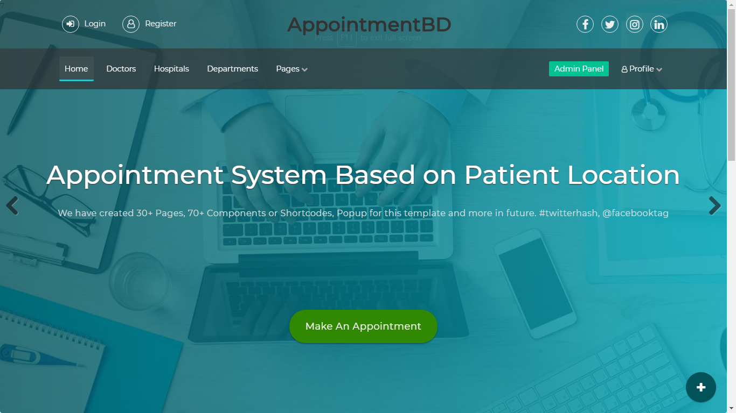

**Fig 8.2.3 : System Dashboard**

* 1. **Summary**

**CHAPTER 9**

**System Testing:**

**9.1 Introduction**

Software testing is an activity to check whether the actual results match the expected results and to ensure that the software system is defect free. It involves execution of a software component or system component to evaluate one or more properties of interest.

Software testing also helps to identify errors, gaps or missing requirements in contrary to the actual requirements. It can be either done manually or using automated tools. Testing can be both manual and also automation.

**9.2 Types of Testing**

Typically Testing is classified into three categories.

* Functional Testing
* Non-Functional Testing
* Maintenance

**9.2 .1 Functional Testing**

Functional Testing is a quality assurance (QA) process and type of black box testing that based on its test cases on the specification of the software component under test cases.

Different types of functional testing are given below:

* Unit Testing
* Integration Testing
* Smoke
* UAT (User Acceptance Testing)
* Localization
* Globalization
* Interoperability

**9.2.2 Non-Functional Testing**

Non-Functional Testing is a testing of a software application or system for its non-Functional requirements the way a system operates, rather than specific behaviors’ of the system

Different types of non-Functional testing are given below:

* Performance
* Endurance
* Load
* Volume
* Scalability
* Usability

**9.2.3 Maintenance**

Once the system is deployed and it is in service for yours and decades. During this time the system and its operational environment is often corrected, changed or extended.

Different types of non-Functional testing are given below:

* Regression
* Maintenance

**9.3 Unit Testing**

Unit testing is a level of of software testing where individual units/components are tested. The purpose is to validate that each unit of the software performs are designed

**9.4 System Testing**

System Testing is a level of the software testing where complete and integrated software is tested. The purpose of this test is to evaluate the system’s compliance with specified requirements.

**9.5 Test Cases of the System**

**Table: 9.1 Test Cases**

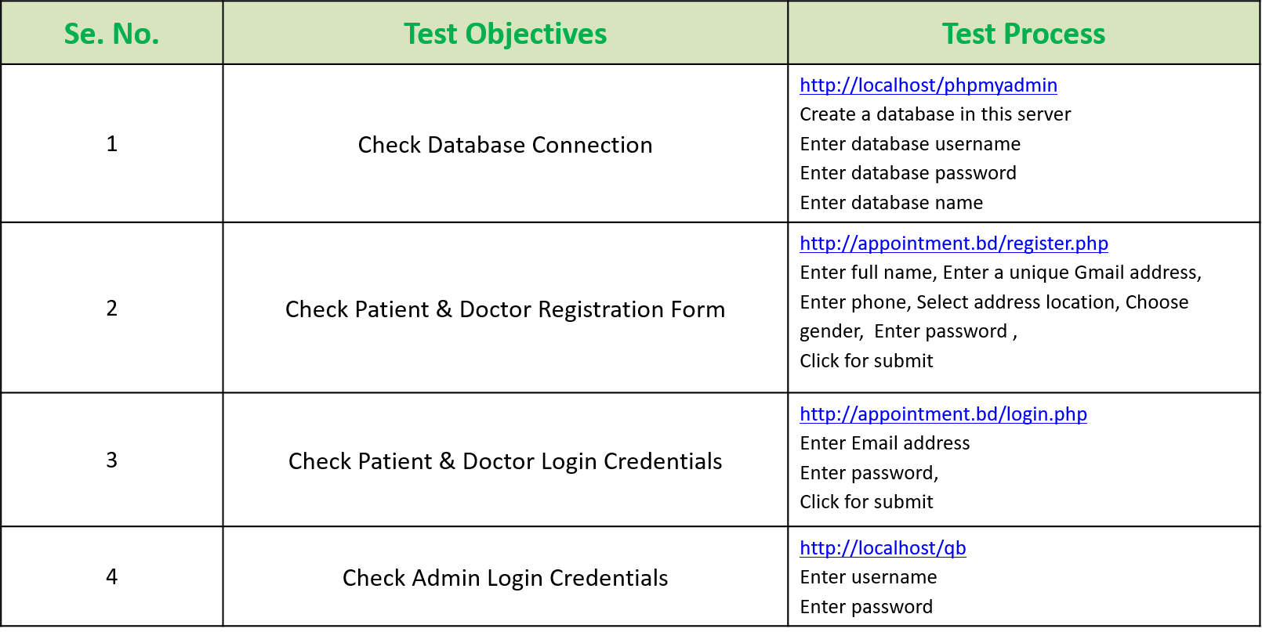

**Table: 9.2 Check Database Connections**

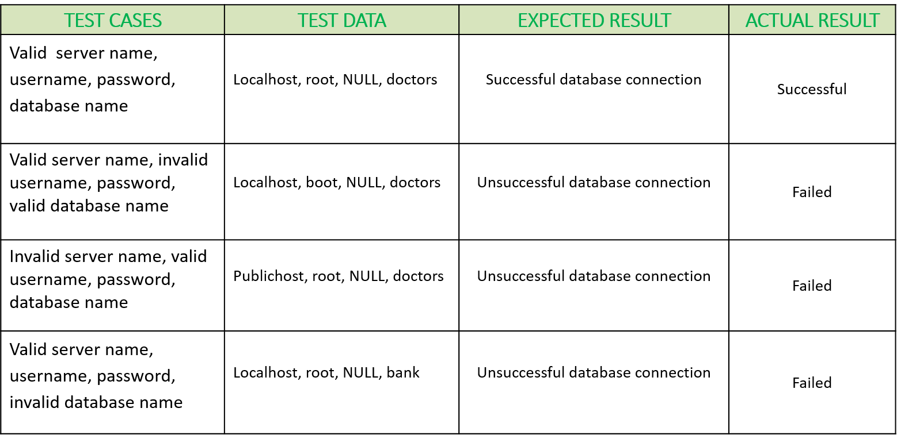

**Table 9.3: Check Patient Registrations From**

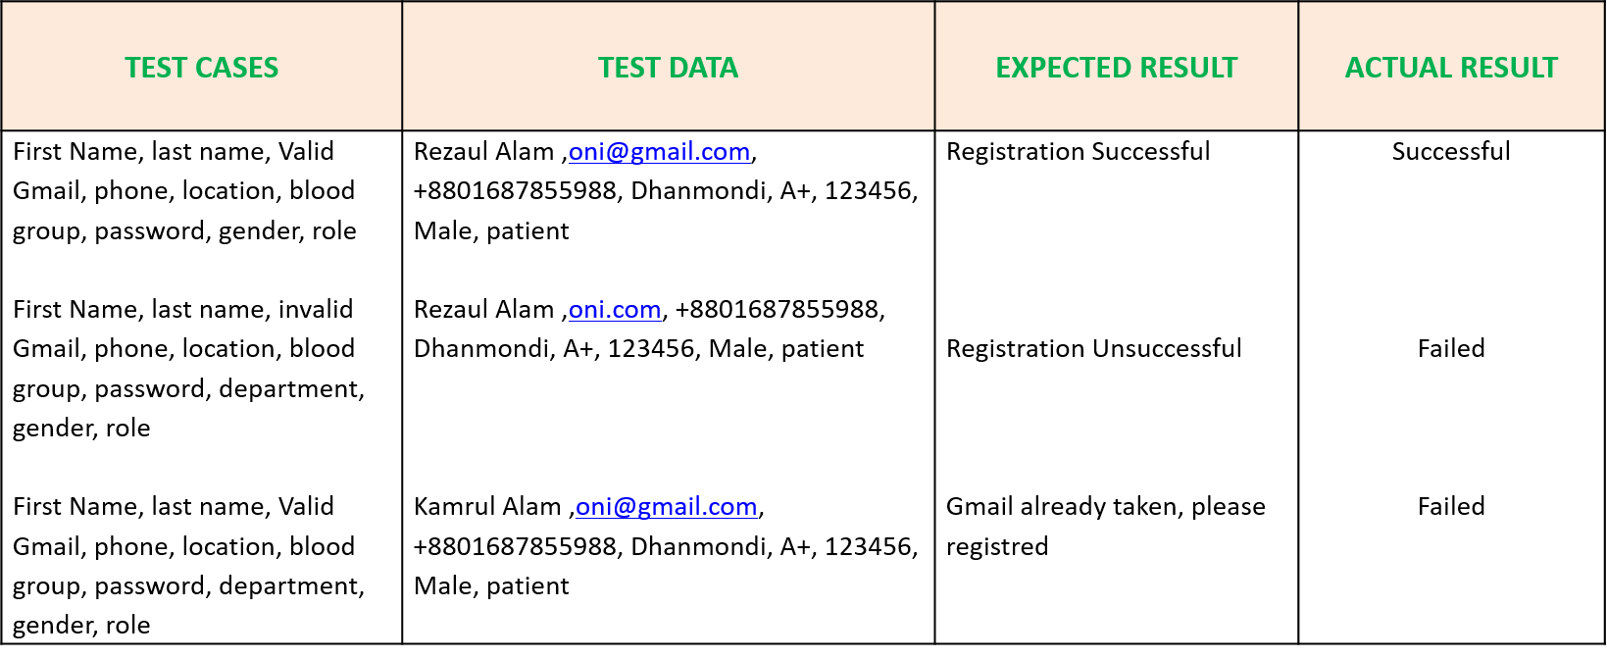

**Table 9.4: Check Doctor Registrations From**

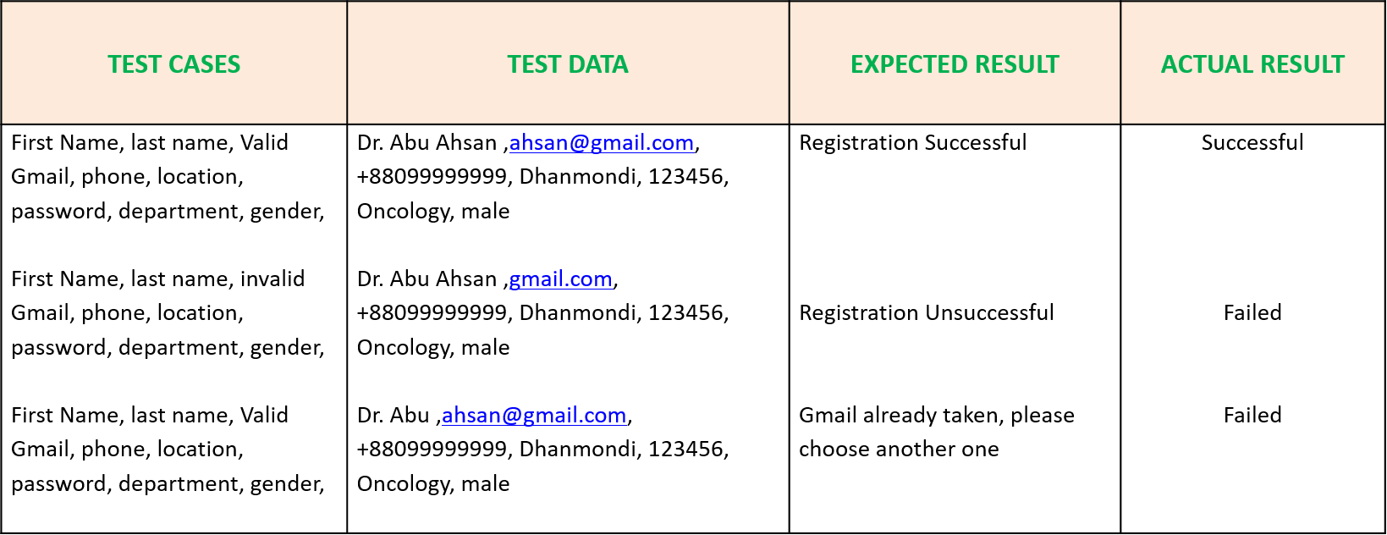

**Table 9.5: Check Patient and Doctor’s login credentials**

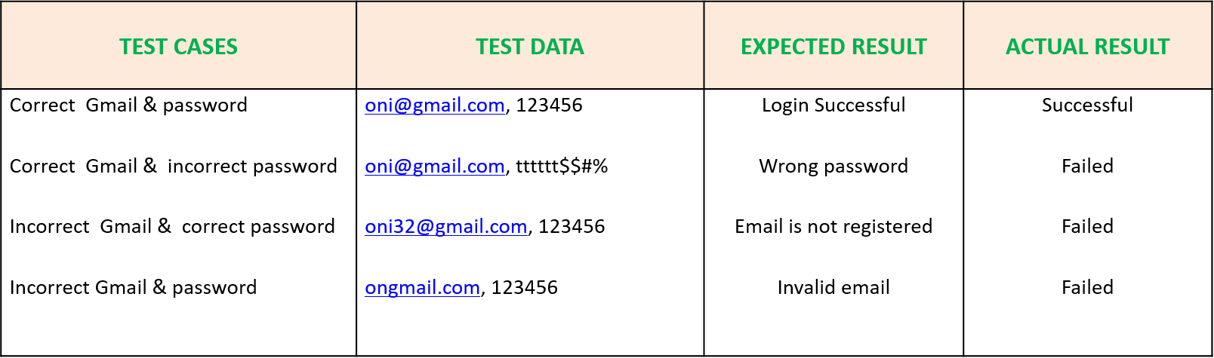

**Table 9.3: Check Admin login credentials**

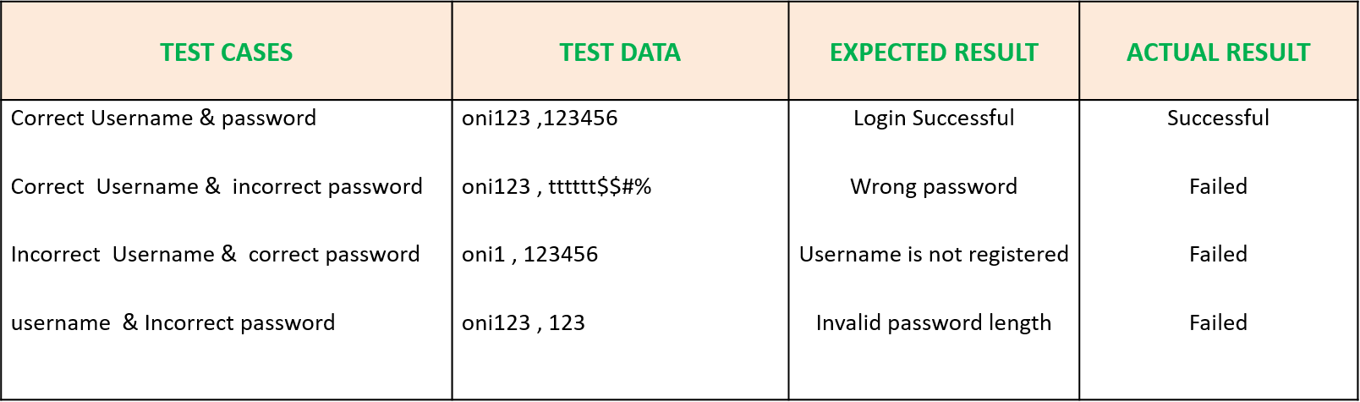

**CHAPTER 10**

**Discussion and Conclusion:**

**9.1 Discussion**

This Doctor’s appointment system will use to get early doctor’s appointment. This system will able to provide nearest hospital or doctor’s chamber appointment as early as possible. This system also able to predict approximately base on user’s input symptom. This system will help people to choose appropriate doctor’s appointment.

**9.2 Conclusion**

The main objectives of the project were to develop an algorithm that will be used to identify answers related to user submitted questions and integrate artificial intelligent to make it better for the users. To develop an interactive api where all the related data will be exposed and to develop a web interface. The web interface developed had two parts, one for simple users and one for the administrator.

**9.3 Future Work**

We develop this system based on people’s requirement in our country. We focused our general people’s requirement in future. We try to finish our work before our final semester.

## References

## [1] World Health Organization. (2018). *World Health Organization*. [Online] Available at: http://www.who.int/en/ [Accessed 6 Feb. 2018].

**[2]** Doctorola. (2018). *Doctorola- Book Appointment With a Doctor Near You!*. [Online] Available at: https://doctorola.com/ [Accessed 10 Feb. 2018].

**[3]** Ibnsinatrust.com. (2018). *Home|Page*. [Online] Available at: http://www.ibnsinatrust.com/ [Accessed 7 Feb. 2018].

**[4]** Sqlite.org. (2018). *About SQLite*. [Online] Available at: https://www.sqlite.org/about.html [Accessed 10 Feb. 2018].

## [5] A. items, “Algorithm for matching similar content text items.” Softwareengineering.stackexchange.com. Available at: [Online] https://softwareengineering.stackexchange.com/questions/188432/algorithm-for-matching-similar-content-text-items [Accessed 5 Feb. 2018].